**This is a critique for Shomi.**

**Navigating through Shomi is extremely difficult and inefficient.**

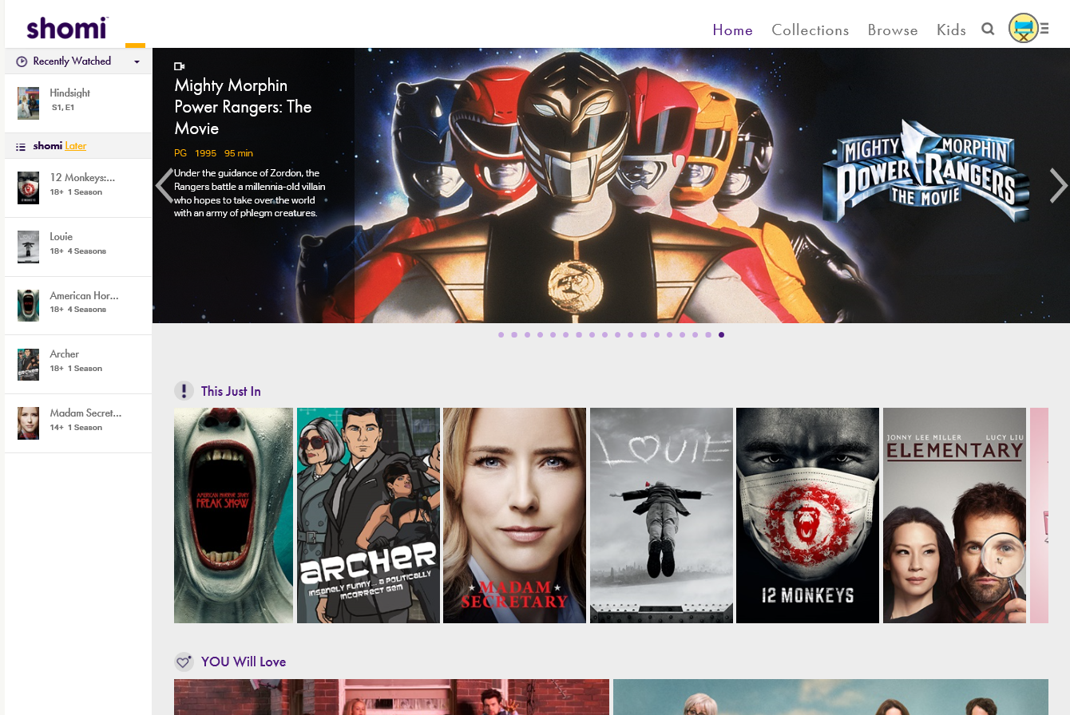

Figure - Recently watched contents and “bookmarked” contents

**Starting off with the main page of Shomi. It suggests contents that may interest you based on your view history and groups them into categories such as “You will like”, “This just in”, etc. It also displays contents that you recently watched and bookmarked to watch later. “Bookmark” and “Recently watched” are neat features because it helps you remember what you planned to watch and where you have left off with previously watched contents. These features are however only accessible from the main page and are disabled once you navigate to another page. This ruins the user experience because they cannot see what they have “bookmarked” and play them directly on their current page.**



Figure - Search in Shomi

**Another flaw with Shomi is the search feature. Shomi’s searching feature is lacking in functionality, it only filters by content title, actor, director, and creator name. If the user wants to watch for example, Fast and Furious, he will not get any result when searching for race or car. This limits the user to only the content in which they knew the name. Furthermore, search filters cannot be cleared once they are set. For example, if the user searches for “Pokémon” and later wants to see all results, they would have start over from the main page.**

**Contents in Shomi are terribly organized.**



Figure - Genre in Shomi

**You cannot pick multiple categories to filter results by. If the user wishes to watch contents that fall in Comedy, Horror, and Action, they would have to select one of the three genres and manually browse until they see contents that fit the other two. Furthermore, there is also no option to search within the current genre or the option to sort results based on rating and popularity.**

**In addition, Shomi displays its content in a grid view, with no text visible.**

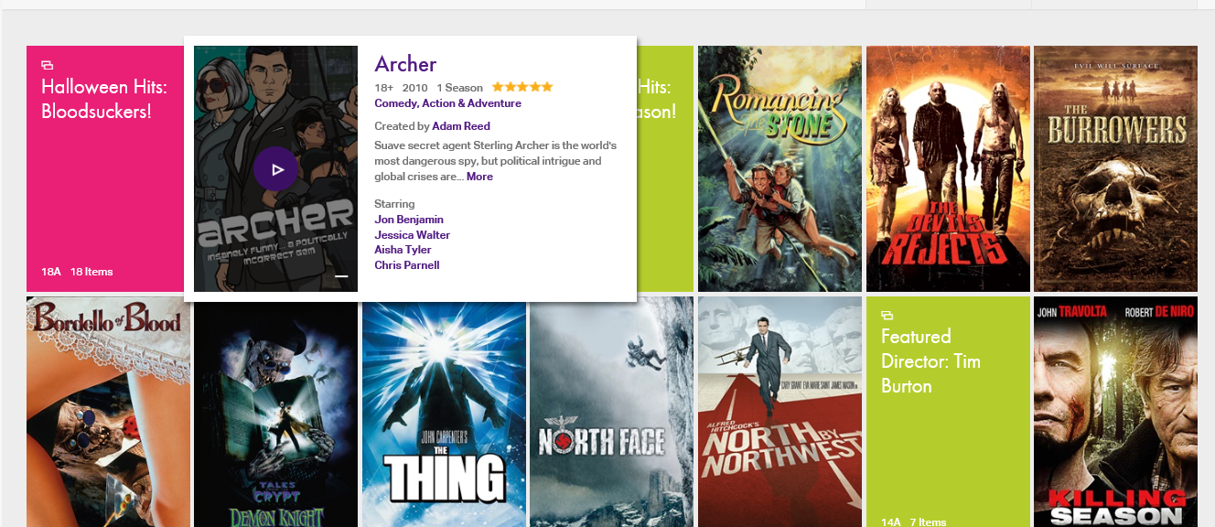

**This keeps the page clean and simple but it also hides critical information from the user. This decision slows down user’s response because they have to hover their mouse over the content to see more details.**